HR Analytics Dashboard

1. **Data Cleaning**

TO know quality of column

View > Column Quality

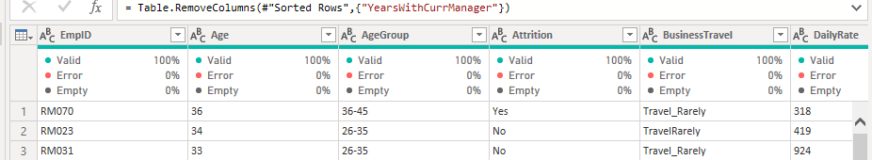

1. **Remove Duplicate :**

Right Click on column then Remove Duplicate

1. To know count of duplicate

Group by > count Rows

Right Click > Number filter > Does not equal to 2 >

1. **Remove Duplicate From All Column**

Select first column then select Last column using SHIFT button then on first column Right Click then REMOVE DUPLICATE

1. Detect Data Type :

Select ALL Column then > Transfer Data > detect Data Type